Snowflake CLI – Homework / Play Tasks

1. Basic CLI Usage

1.1 Check the Snowflake CLI version:

Snow –version

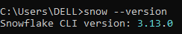

1.2 Test your connection to Snowflake using the CLI:
- - Snow connection add
- - Snow Connection Test -- connection hari-con
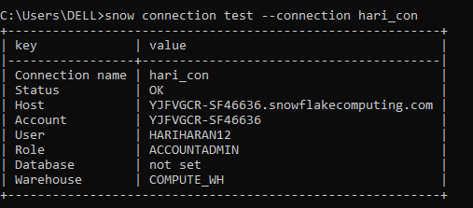

2. Running Simple SQL

2.1 Run a SQL command to show all databases.

snow sql -c hari_con -q "show Databases;”
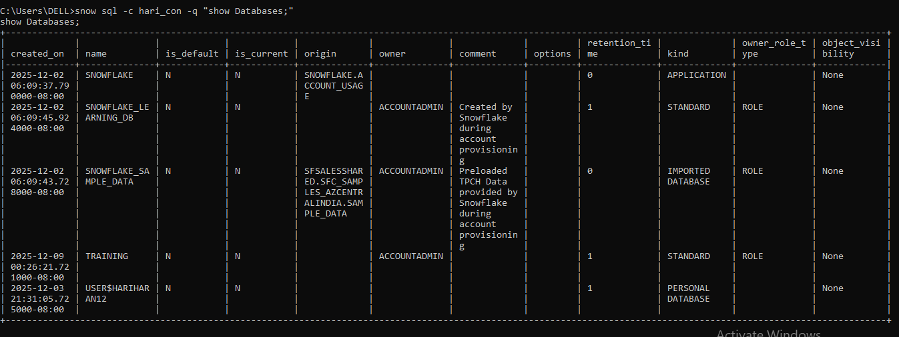

2.2 Run a SQL command to show all warehouses.
snow sql -c hari_con -q "show warehouses;"
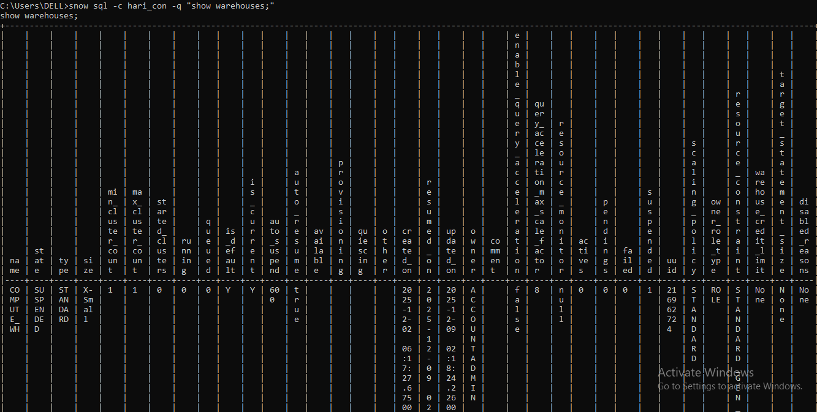

2.3 Run a SQL file using the Snowflake CLI.

- -snow sql -c hari_con -f "C:\Users\DELL\Documents\cliassignment.sql"
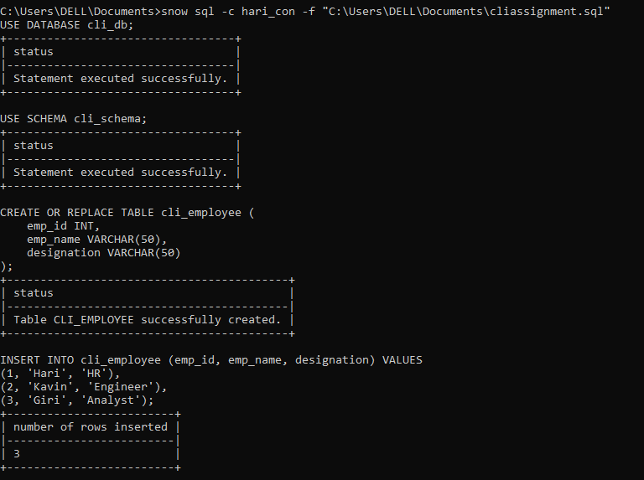

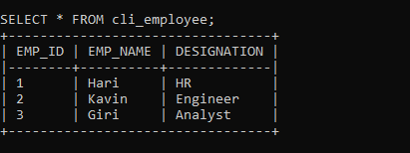

3. Creating Objects

3.1 Create a database using the CLI.

Snow sql -c hari_con -q “CREATE OR REPLACE cli_db;”

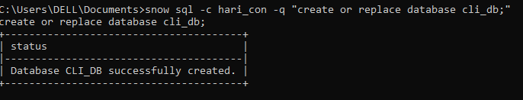

3.2 Create a schema inside that database
Snow sql -c hari_con -q “create or replace cli_db.cli_schema;”

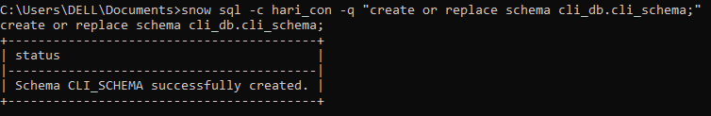

3.3 Create a table using a SQL file and run it through the CLI.
cd C:\Users\DELL\Documents - - - First we change the directory in our file location
snow sql -c hari_con -f cliassignment.sql - - - And we put file name

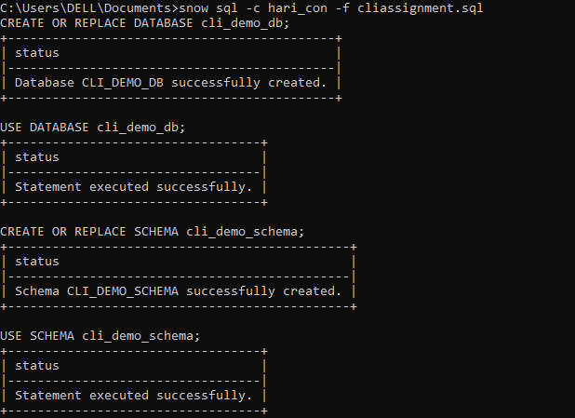

4. Working With Stages

4.1 Upload a small CSV file to an internal stage using the CLI.

snow sql -c hari_con -q “create or replace stage cli_db.cli_schema.cli_stage;”

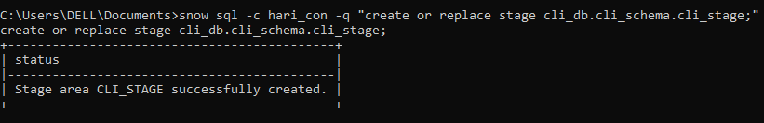

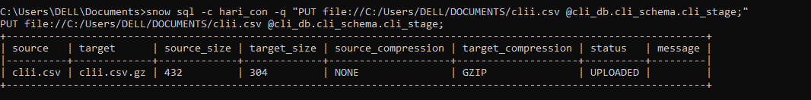

4.2 List the files inside the stage.

snowsql -c hari_con -q "LIST @cli_db.cli_schema.cli_stage;"
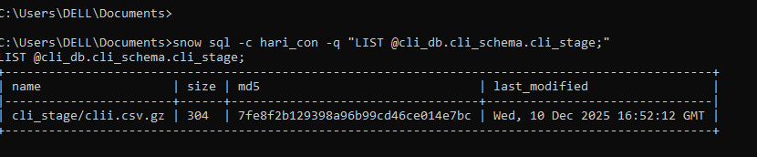

4.3 Download the uploaded file back to your computer.
Snow sql -c hari_con -q “Get @cli_db.cli_schema.cli-stage/clii.csv file://c:/Users/DELL/Downloads/;”

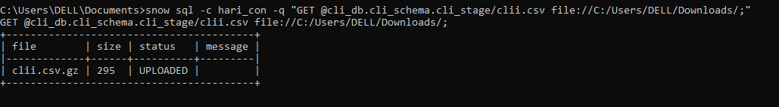

5. Loading and Unloading Data

5.1 Load CSV data into a table using COPY INTO via the CLI.

Snow sql -c hari_con -q “create or replace table cli_db.cli_schema.cli_emp(emp_id int,emp_name varchar(50),designation varchar(50));

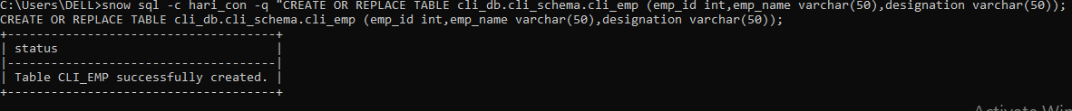

Snow sql -c hari_con -q “PUT file://c:/users/dell/documents/clidata.csv @cli_db.cli_schema.cli_stage;”

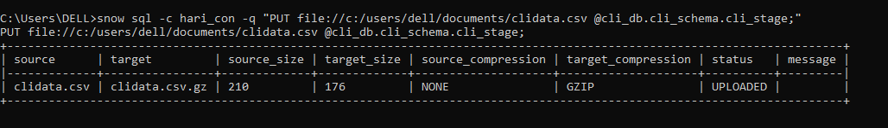

Snow sql -c hari_con -q “copy into cli_db.cli_schema.cli_emp from @cli_db.cli_schema.cli_stage File_Format=(Type = csv Skip_Header=1)on_error=continue;”
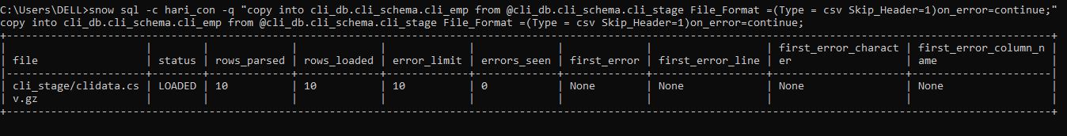

5.2 Unload data from a table into a stage.
Snow_sql -c hari_con -q “copy into @cli_db.cli_stage from cli_db.cli_schema.cli_emp File_Format=(TYPE=CSV) OVERWRITE=TRUE;”
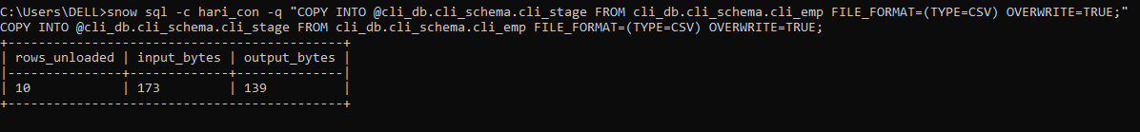

6. Deploying a Snowflake Project

Initialize a Snowflake project using snow init.

Deploy the project using snow deploy.

7. Query Output Practice

7.1 Run a SELECT query and save the results to a CSV file using the CLI.

Snow sql -c hari_con -q "SELECT * FROM cli_db.cli_schema.cli_emp;" -o output_format=csv -o output_file="C:\Users\DELL\Downloads\mydata.csv"

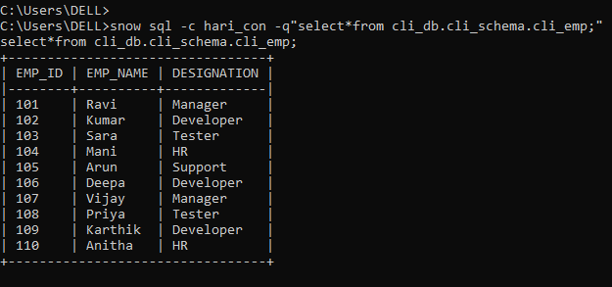
Snow sql -c hari_con -q “select*from cli_db.cli_schema.cli_emp;”> c:\users\DELL\Downloads\emp.csv

7.2 Try different output formats such as pretty, CSV, and JSON.
C:\Users\DELL>snow sql -c hari_con -q "SELECT * FROM cli_db.cli_schema.cli_emp;" > C:\Users\DELL\Downloads\emp.json

8. Playing With Context

8.1 Change the warehouse while running a query.
Snow sql -c hari_con -q "use warehouse cli_wh;select*from cli_db.cli_schema.cli_emp;"
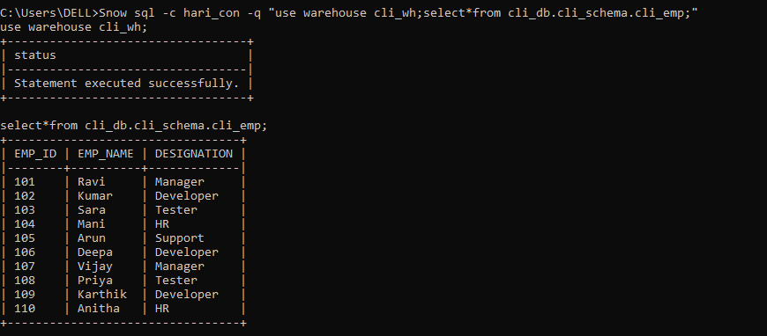
8.2 Change the database and schema using CLI options.
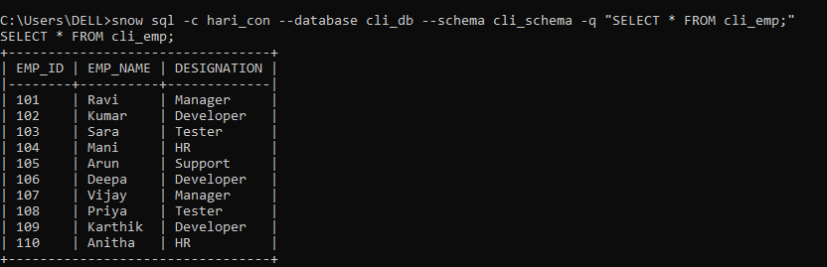

9. Troubleshooting and Help

9.1 Use the help command to list all available CLI commands.

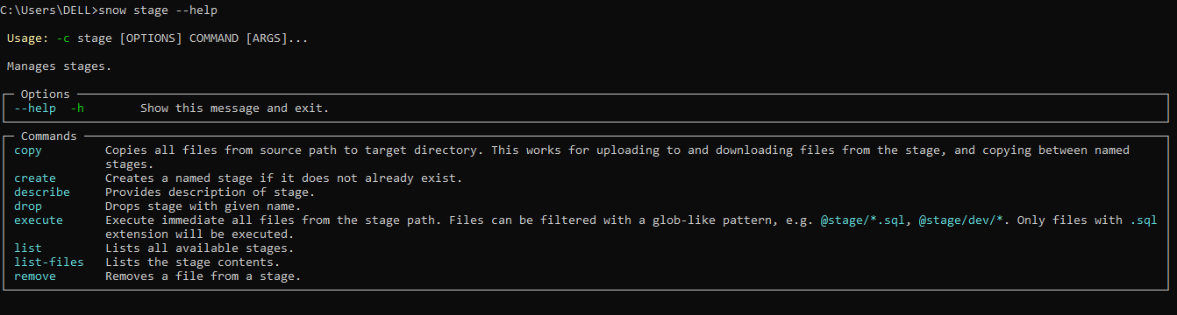

9.2 Run a command in verbose mode to view detailed logs.

- Verbose mode shows you everything that’s happening behind the scenes when a command runs.
- It gives extra details like steps, logs, and hidden messages that you normally don’t see.
- We use it to easily understand problems and figure out why something didn’t work.
Snow sql -c hari_con --verbose -q “SELECT CURRENT_DATE();”

